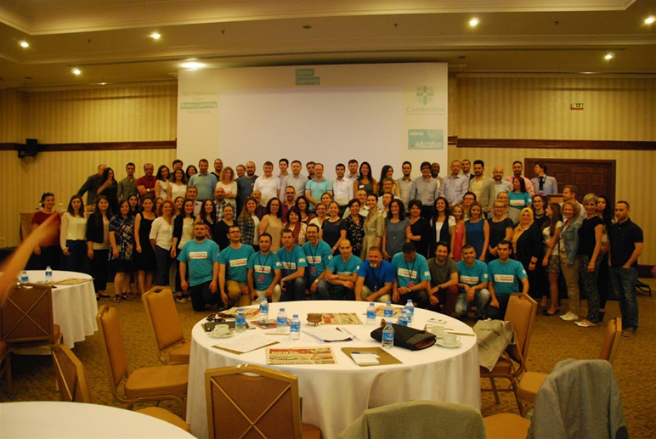
The speakers and the abstracts:
Peter Lucantoni
Teacher Trainer and Author, Cambridge University Press
UNLOCK: Overview and Methodology
Peter looked at where Unlock sits in terms of international standards, and discuss how the course methodology and unit structure provide learners with scaffolded practice in order to effectively develop their language and critical thinking skills
Jim Scrivener
Freelance ELT Trainer & Author
Uncertainty
As ELT professionals, it feels as if we work in a world of increasing certainties. Researchers measure and quantify what we do and make proposals about best practice. Course books (and presumably their writers and publishers) seem to have worked out how best to organise learning content for the classroom. School owners and their management teams tell students that they know how long it will take them to progress through each level – and they tell teachers exactly how long they should take to cover each unit of the book. Inspectors seem to know exactly what they are looking for when they observe our lessons.
So… …why do I still feel so unsure about everything?
This talk is an exploration of uncertainty in ELT (and the lack of it). The implications for teaching are surprisingly important and far-reaching.

Jim Scrivener
Freelance ELT Trainer & Author
Demand High with an Academic Text
Demand High is an approach to teaching that encourages teachers to get away from simply moving through exercises and checking correct answers.
Even with the best course book, teachers often feel the need to push a little bit more and go a little bit deeper, especially with the potentially routine work of analysing academic texts. So, what can a teacher do beyond following through the exercises and tasks in the book? How could a teacher help students start to learn to think more, remember more, challenge themselves more and read between the lines more? This very practical session offers a demonstration of some instantly usable classroom ideas.
Jim Scrivener
Freelance ELT Trainer & Author
Down the Rabbit Hole: The New Science and Skills of Reading
Reading is evolving dramatically away from a reflective “listening to the dead with our eyes”.
• Is it getting harder to read a book?
• Are our brains rewiring for different dynamic online reading skills?
This entertaining session reviews the latest scientific thinking on what reading is and asks whether ELT’s description of skills is still relevant on iPads or in your classroom.
Adrian Doff
Writer and Teacher Trainer
The teacher as listener: informal assessment in the classroom
An important part of teaching is being able to evaluate learners’ progress. The teacher can often achieve this informally in class as well as by using more formal kinds of assessment. This workshop looks at principles of ‘Learning Oriented Assessment’ and how they can be applied in everyday classroom teaching. We consider ways in which emphasising the teacher’s role as evaluator can affect the way we view common classroom procedures. We also consider more extended uses of learning oriented assessment in class, such as monitoring and recording, using diagnostic activities and using ‘can do’ statements as an evaluation tool. Finally, we will look at how the principles of Learning Oriented Assessment can be applied to more formalised assessment and feedback, with examples from the online assessment package accompanying CUP’s new adult course Cambridge English Empower.

